Dr. Smith’s

PUNCH AND JUDY SHOW

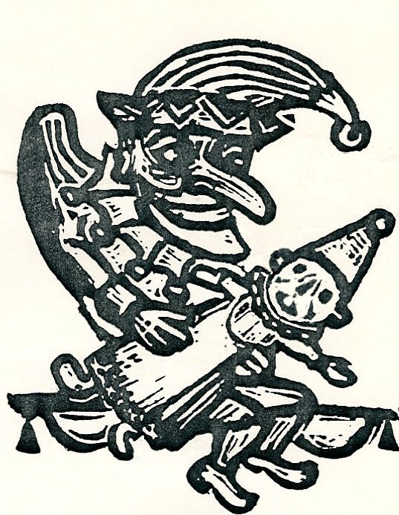
Mr. Punch entertains with mischief, mayhem and murder.
The wicked Mr. Punch cannot take anything seriously.
Cheer him on as he wreaks havoc among family and foes.
This is the traditional British show, uncensored but suitable for anyone over 5.

It’s shocking!
It’s terrible!
It should be banned!
Long live Mr. Punch!

Contact: peter@sandsmith.com

